VEHICLE RENTAL SYSTEM

Project Report

Submitted To
Course Teacher
Department of Computer Science and Engineering

Submitted By: Group-5
Name: Samira Hasan ID:- 1121003
Name: Jakia Sultana Jerin ID:- 1121027
Name: Tasnim Taaha ID:- 1121029
Name: Mariya sultana ID:- 1121038
Department: Computer Science and Engineering (CSE)
Semester: 2-1
Course Title: Object Oriented Programming (OOP)
Course Code: CSE: 214

Project Title

Vehicle Rental System

Submission Date
19-07-2026

1. Objective
The main objective of this project is to develop a simple and user-friendly Vehicle Rental System using Object-Oriented Programming (OOP) in C++. The system helps manage vehicles, customers, rentals, and notes efficiently. It also demonstrates the practical implementation of OOP concepts along with file handling and exception handling.
The objectives of this project are:
- To store vehicle information in a structured manner.
- To manage customer information efficiently.
- To rent vehicles to customers.
- To return rented vehicles and update their availability.
- To maintain rental history.
- To save all records permanently using text files.
- To implement Object-Oriented Programming concepts such as Encapsulation, Inheritance, Polymorphism, Friend Function, Constructors, and Destructors.
- To handle invalid user input using Exception Handling.
- To provide a simple menu-driven console application for users.

2. Problem Description
Many small vehicle rental businesses maintain their customer and vehicle information manually using notebooks or paper records. This traditional method is time-consuming and increases the possibility of data loss and human error.
The Vehicle Rental System was developed to solve these problems by computerizing the entire rental management process. The system allows the user to add, update, search, and delete vehicle and customer information. It also provides vehicle rental and return facilities while automatically calculating the rental bill.
The system stores all information in text files so that data remains available even after closing the program. When the application starts, previously saved information is automatically loaded into memory. This reduces manual work and improves efficiency.
Overall, the project provides a simple, reliable, and organized solution for managing vehicle rental operations using C++ and Object-Oriented Programming techniques.

3. Features Implemented
The Vehicle Rental System provides several useful features to manage vehicles, customers, rentals, and notes efficiently. The main features implemented in this project are listed below.

3.1 Vehicle Management
- Add a new vehicle.
- Display all available vehicles in a professional table format.
- Search a vehicle using Vehicle ID.
- Update vehicle information.
- Delete a vehicle from the system.
- Automatically save vehicle information into a text file.

3.2 Customer Management
- Add a new customer.
- Display all customer information.
- Search customer by Customer ID.
- Update customer information.
- Delete customer information.
- Automatically save customer records into a text file.

3.3 Vehicle Rental
- Rent a vehicle to a customer.
- Verify Customer ID and Vehicle ID before renting.
- Check vehicle availability.
- Automatically calculate the total rental bill.
- Store rental information permanently in a text file.
- Change vehicle status from Available to Rented.

3.4 Return Vehicle
- Return a rented vehicle.
- Update the vehicle status from Rented to Available.
- Save the updated status automatically.

3.5 Rental History
- Display all rental records.
- Show Rental ID, Customer ID, Vehicle ID, Number of Days, and Total Bill.
- Store rental history permanently.

3.6 Notes Management
- Add important notes.
- View all saved notes.
- Store notes in a separate text file.

3.7 File Handling
- Store all data permanently.
- Automatically load saved data when the program starts.
- Save data after adding, updating, deleting, renting, and returning vehicles.

3.8 Exception Handling
- Detect invalid Customer ID.
- Detect invalid Vehicle ID.
- Detect invalid rental days.
- Display appropriate error messages without terminating the program.

4. OOP Concepts Used

The Vehicle Rental System has been developed by implementing various Object-Oriented Programming (OOP) concepts. The implementation details are described below.

4.1 Class and Object
The project is developed using multiple classes to organize the program into different modules. Each class represents a real-world entity.
Classes used in this project:
- Vehicle
- Person
- Customer
- Rental
Objects of these classes are created using arrays such as:
Vehicle vehicles[100];
Customer customers[100];
Rental rentals[100];
These objects are used throughout the program to store and manage data.

4.2 Encapsulation
Encapsulation is implemented by declaring data members as private and accessing them through public member functions.
Example from the Vehicle class:
private:
int vehicleID;
string vehicleName;
string brand;
float rentPerDay;
string status;
These private variables are accessed using public functions such as:
getID()
getName()
getBrand()
getRent()
getStatus()
setStatus()
Similarly, the Customer and Rental classes also use private data members with public getter functions.

4.3 Inheritance
Inheritance is implemented by creating the Customer class from the Person class.
class Customer : public Person
The Customer class inherits the following members from the Person class:
- id
- name
- displayInfo()
This reduces code duplication and improves code reusability.

4.4 Polymorphism (Function Overriding)
Polymorphism is implemented using virtual functions.
The base class (Person) declares:
virtual void displayInfo();
The derived class (Customer) overrides it:
void displayInfo() override
This allows different implementations of the same function depending on the object type.

4.5 Constructor
Constructors are used to initialize object data automatically.
The project contains:
Default Constructor
Vehicle()
Customer()
Rental()
Parameterized Constructor
Vehicle(int id, string name, string vehicleBrand, float rent, string vehicleStatus)

Customer(int i, string n, string p, string a)

Rental(int rID, int cID, int vID, int days, float bill)
Constructors reduce manual initialization and improve program efficiency.

4.6 Destructor
A destructor is implemented in the Vehicle class.
~Vehicle()
{
}
Although no special cleanup operation is required, the destructor is included to demonstrate object destruction in Object-Oriented Programming.

4.7 Friend Function
A Friend Function is used to access the private members of the Vehicle class directly.
friend void showVehicleDetails(Vehicle v);
This function displays all private information of a vehicle without using getter functions.

4.8 Dynamic Memory Allocation
Dynamic Memory Allocation is demonstrated using the new and delete operators.
Example:
Vehicle *v = new Vehicle();

delete v;
This demonstrates dynamic object creation and memory management during program execution.

4.9 File Handling
File Handling is implemented using:
- ifstream
- ofstream
Files used:
- vehicle.txt
- customer.txt
- rental.txt
- notes.txt
Functions used:
- saveData()
- loadData()
- saveCustomerData()
- loadCustomerData()
- saveRentalData()
- loadRentalData()
These functions permanently store and retrieve project data.

4.10 Exception Handling
Exception Handling is implemented inside the rentVehicle() function.
The program uses:
try
throw
catch
The program throws exceptions when:
- Customer ID is invalid.
- Vehicle ID is invalid.
- Number of rental days is less than or equal to zero.
The catch block displays an appropriate error message without terminating the program, making the system more reliable and user-friendly.

4.11 Abstraction
Abstraction is implemented through the Person base class.
The common properties (id and name) and the virtual function displayInfo() are defined in the base class, while the implementation is provided in the derived Customer class.
This hides implementation details and exposes only the required functionality to the user.

5. UML Class Diagram
The Vehicle Rental System is developed using four main classes. The relationship among the classes is shown below.

person
id
name
displayInfo()

Inheritance

Customer
phone address
inputCustomer() displayInfo()

Vehicle
vehicleID vehicleName brand rentPerDay status
inputVehicle() displayVehicle()
getID()
getName()
getBrand()
getRent()
getStatus()
setStatus()
isAvailable()

Rental
rentalID customerID vehicleID totalDays totalBill
displayRental() getRentalID()
getCustomerID()
getVehicleID()
getDays()
getBill()

6. Program Flowchart
Start


Welcome Screen


Load Saved Data



Main Menu



Vehicle | Customer | Rental | Return

Save Updated Data


Display Result


Continue / Exit



End

7. Sample Input and Output

Sample Input
Enter Vehicle ID : 101
Enter Vehicle Name : Corolla
Enter Brand : Toyota
Enter Rent Per Day : 3500

Enter Customer ID : 201
Enter Customer Name : Rahim
Enter Phone Number : 01712345678
Enter Address : Dhaka

Enter Number of Days : 5

Sample Output
==================================================
VEHICLE RENTED SUCCESSFULLY
==================================================
Rental ID : 1
Customer ID : 201
Vehicle ID : 101
Total Bill : 17500 TK
==================================================

8. Screenshots.
Welcome Screen:- Displays the welcome message when the program starts.
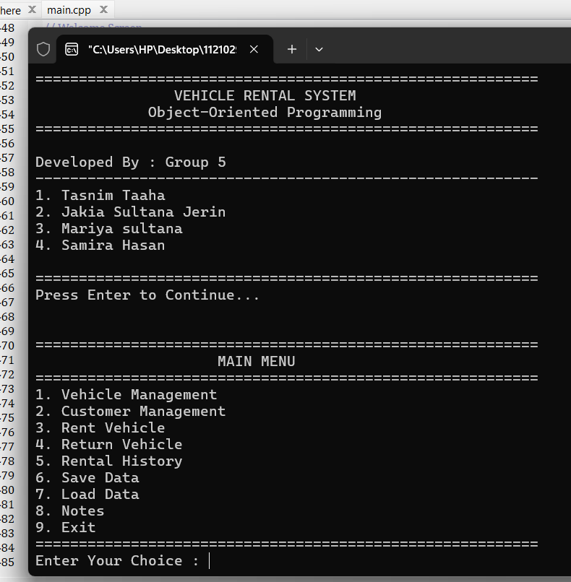
Main Menu:- Shows the main options of the Vehicle Rental System.
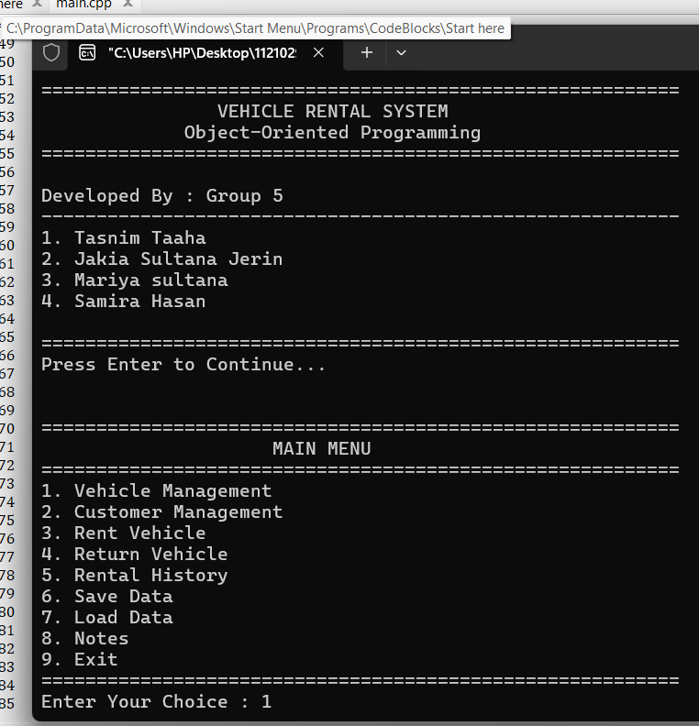
Vehicle Management Menu- Provides options to manage vehicle records.
Add Vehicle
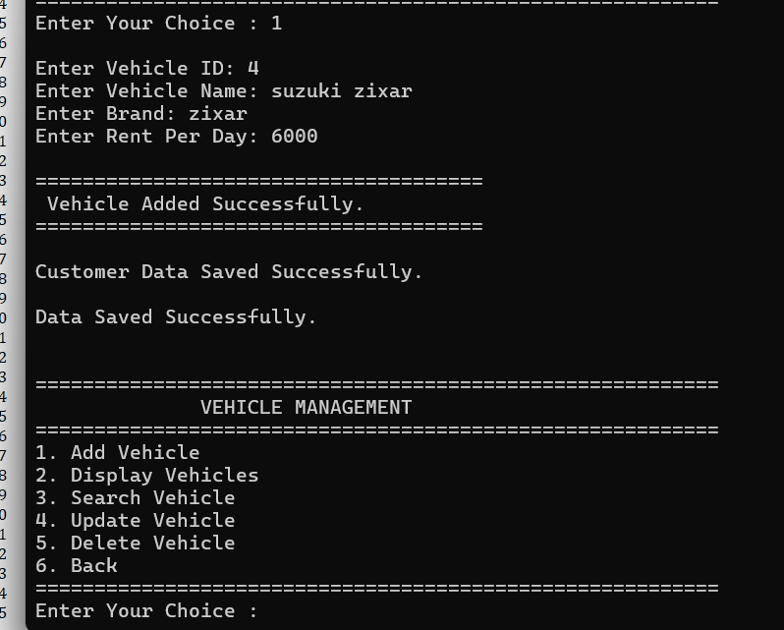
Display Vehicles:- Displays all available vehicle records in a table format.
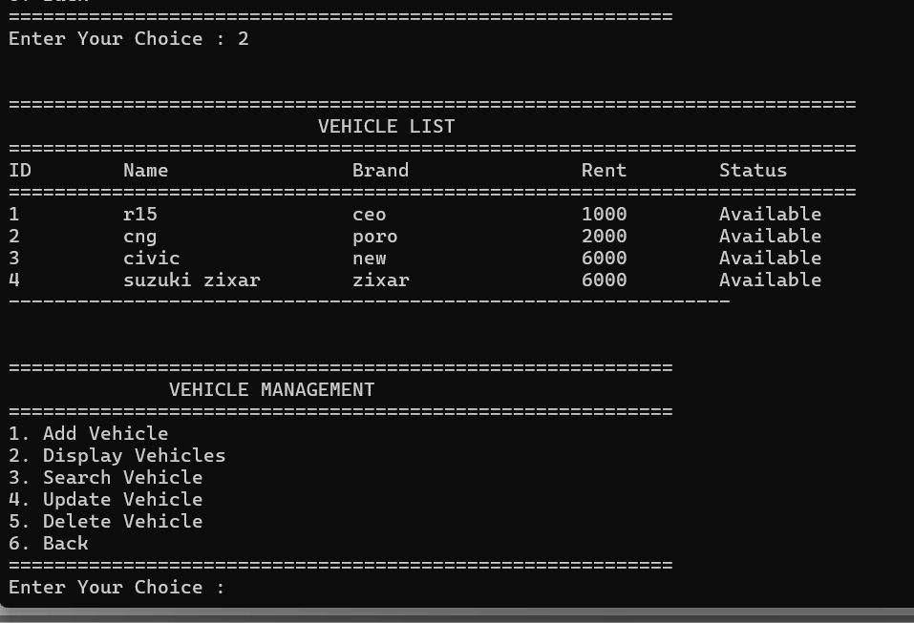
Scarch Vehicle
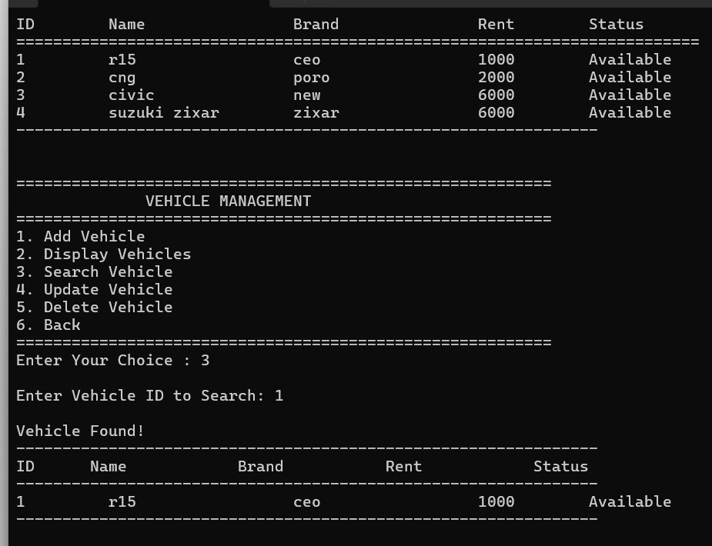
Customer Management Menu:- Provides options to manage customer information.
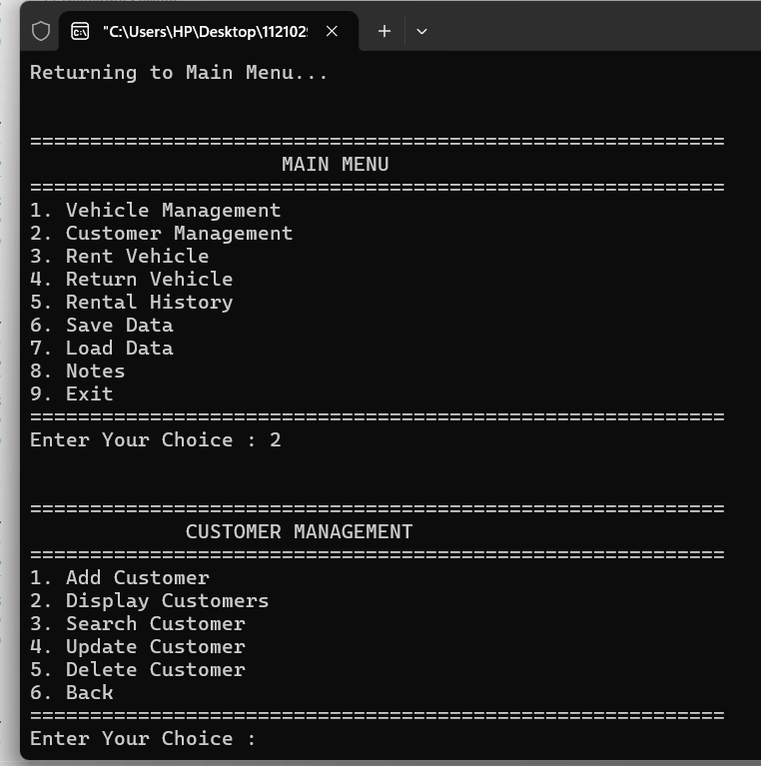
Add Customer:- Allows the user to register a new customer.
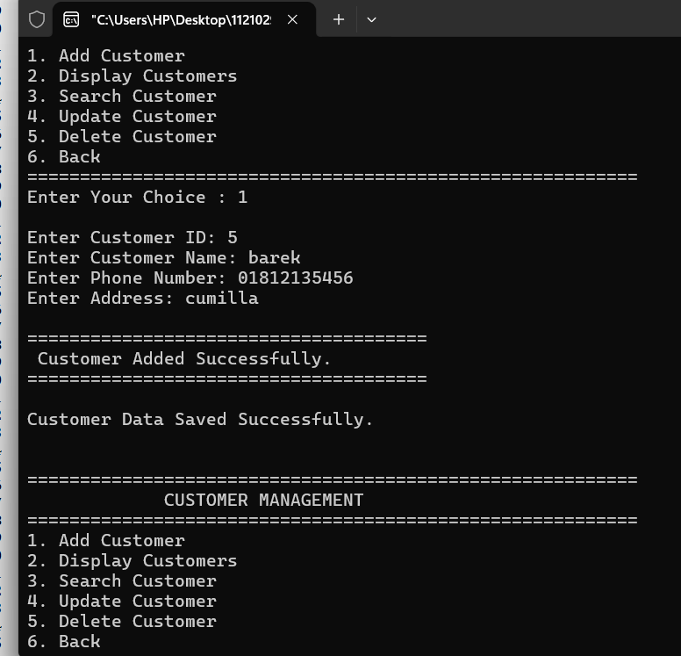
Display Customers:- Displays all customer information in a table format.

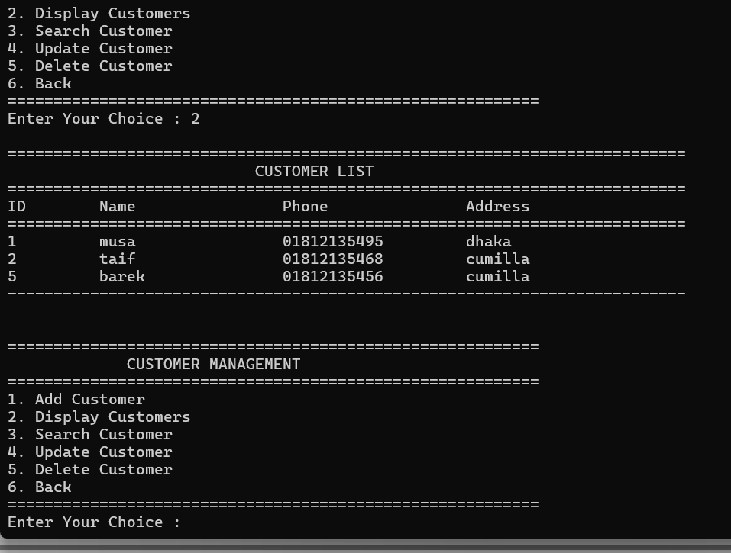
Rent Vehicle :- Allows a customer to rent an available vehicle.
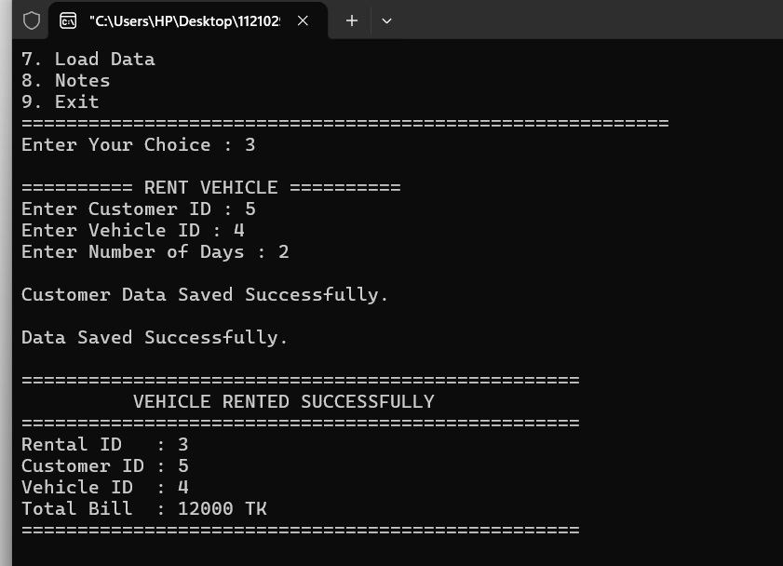
Return Vehicle:- Updates the vehicle status after it is returned.
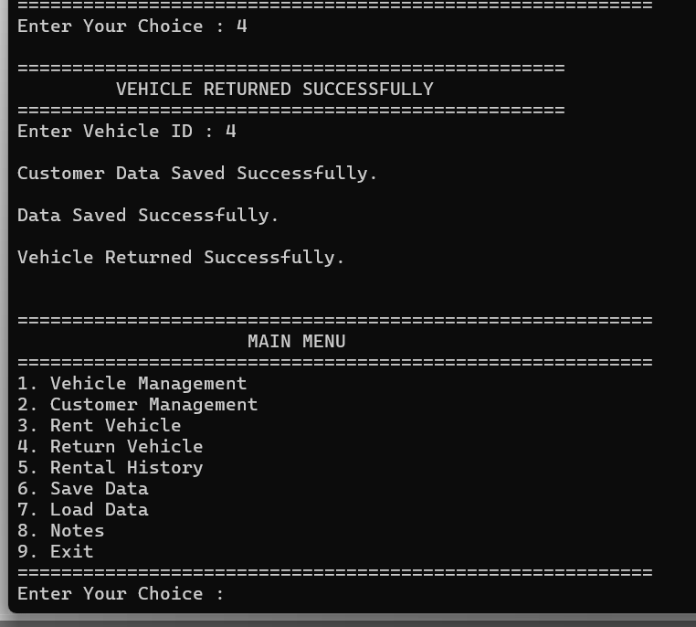
Rental History:- Displays all previous rental records.
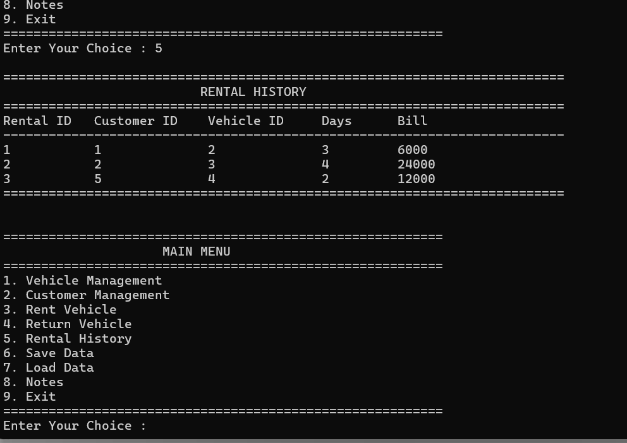
Notes:- Shows and manages important notes stored in the system.
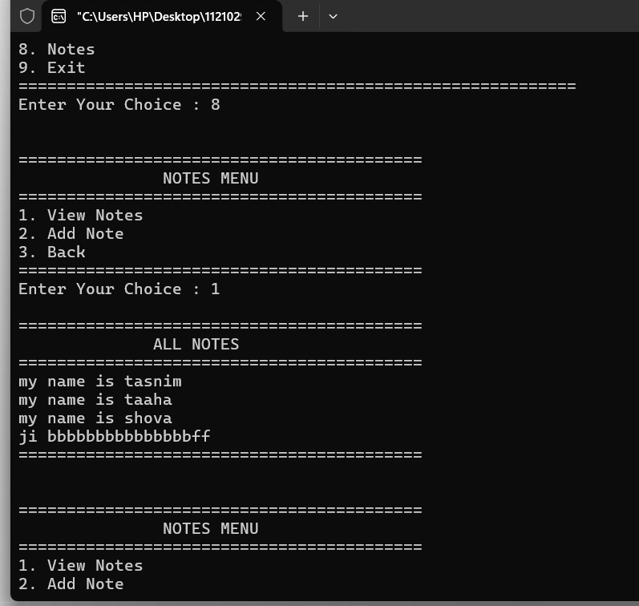
Data Saved Successfully:- Confirms that all data has been saved successfully.
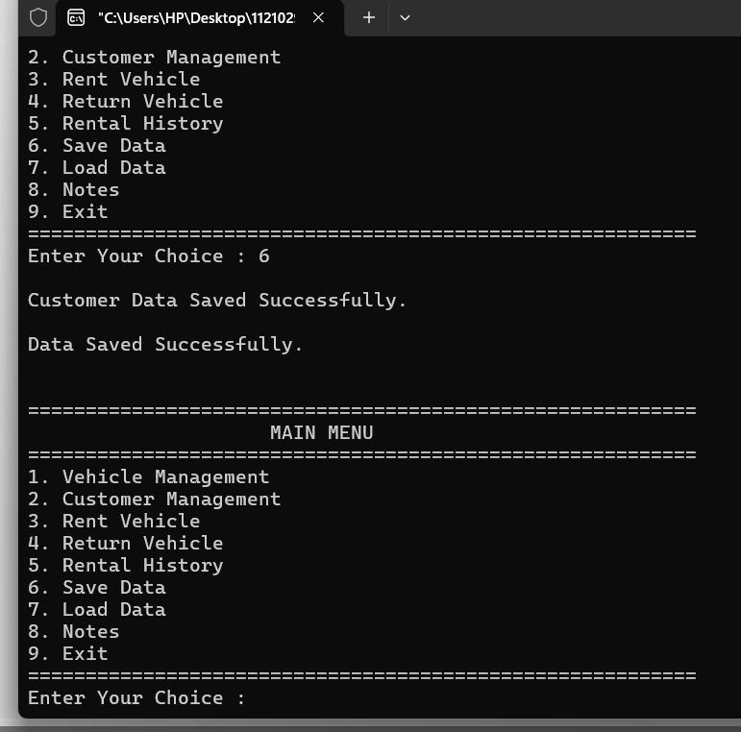
Data Loaded Successfully:- Confirms that previously saved data has been loaded successfully.
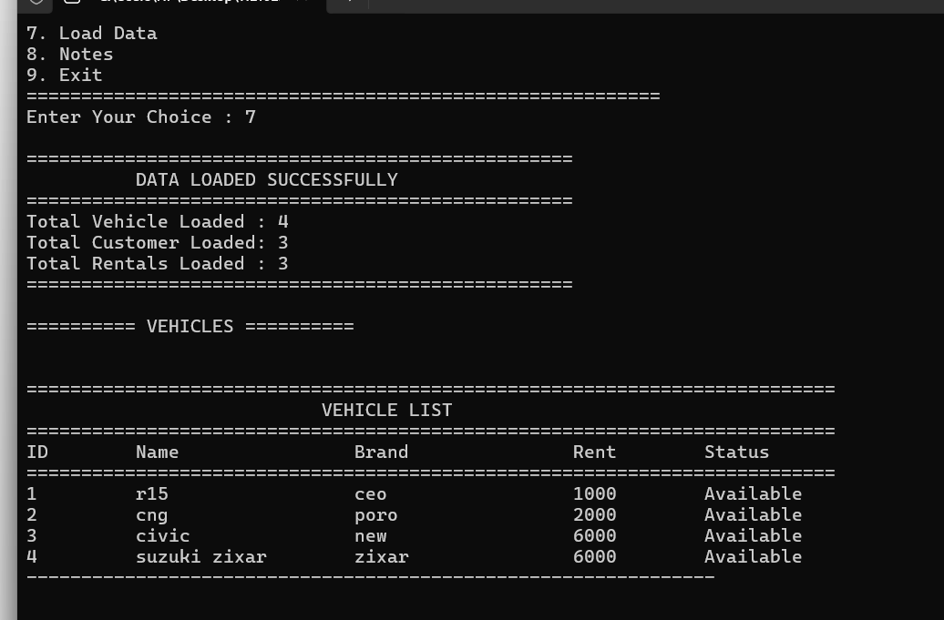
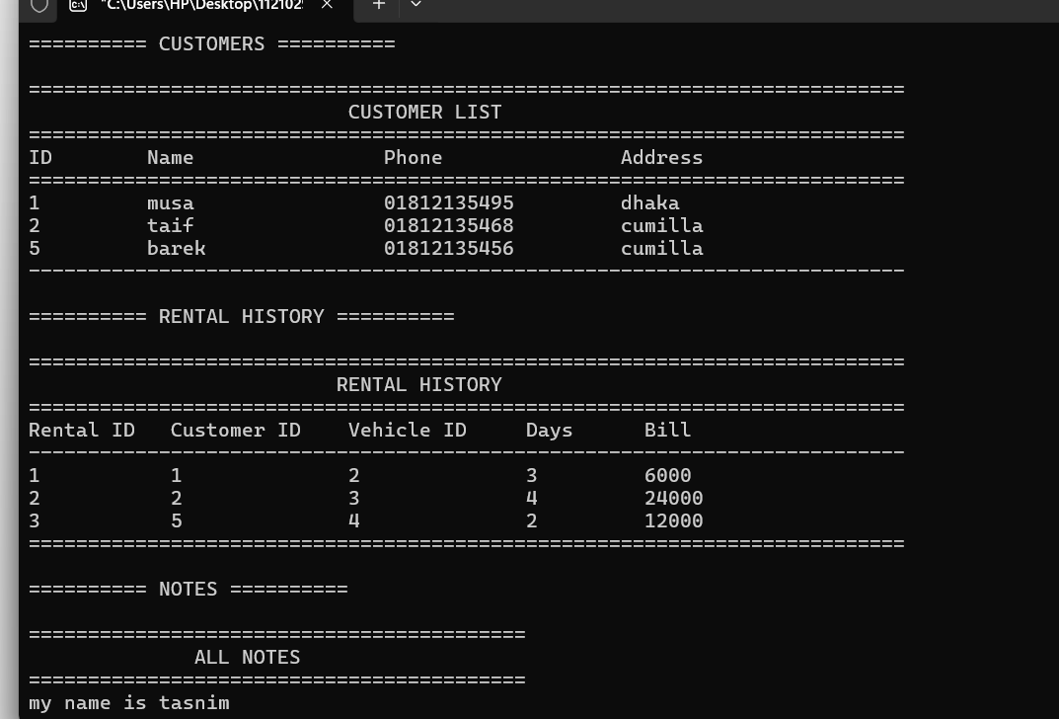

9. Conclusion
The Vehicle Rental System successfully fulfills all the required objectives of the project. The application provides an efficient solution for managing vehicle rental operations through a simple console-based interface.
The system allows users to manage vehicles, customers, rentals, and notes effectively while maintaining data permanently through file handling. It also demonstrates the practical implementation of Object-Oriented Programming concepts such as Encapsulation, Inheritance, Polymorphism, Constructors, Destructors, Friend Function, Dynamic Memory Allocation, and Exception Handling.
Overall, this project enhanced the understanding of OOP principles, file handling techniques, and real-world software development practices. The developed system is simple, reliable, user-friendly, and can be further extended into a complete graphical or web-based application in the future.

10. References
- Bjarne Stroustrup, Programming: Principles and Practice Using C++.
- Bjarne Stroustrup, The C++ Programming Language.
- Cplusplus.com. Available at: https://cplusplus.com
- GeeksforGeeks. Available at: https://www.geeksforgeeks.org
- Mousumi Hasan Mukti. (2026). Object-Oriented Programming (OOP) Lecture Notes. Department of Computer Science and Engineering, [BAIUST].
- Course Materials and Laboratory Manuals, Object-Oriented Programming (OOP), Department of Computer Science and Engineering.

